Project Alpha – Code Review

Include ZM_COI3WC_ZXMBCU04

- Please don’t use ‘Exit’ in an include – ‘Exit’ is fine in a Form or a method but here it will try to exit the User exit . So if someone places a code after your include may not get triggered if an ‘EXIT’ statement is encountered.
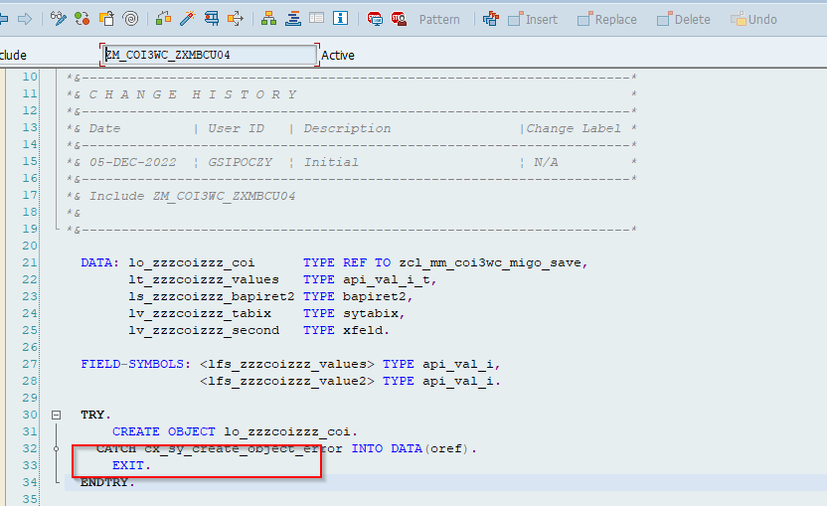

Handle with ‘IF lo_zzzcoizzz_coi’ is not initial and ‘Endif’ please.

- The param entry is not scalable solution . It is always expecting that there will be just 1 record for purch. Org , and that too in value 1 . Always consider the scenario where it can scale out.
Method - CHECK_COI_NEEDED_GR_INT
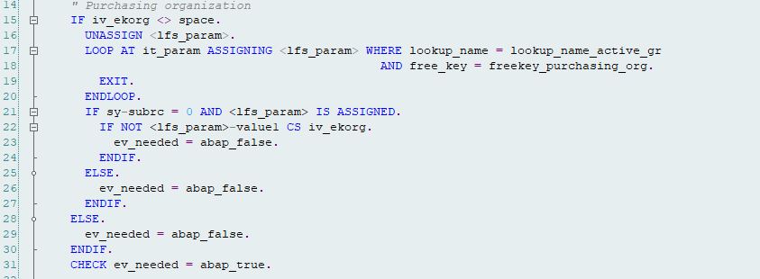

Same here
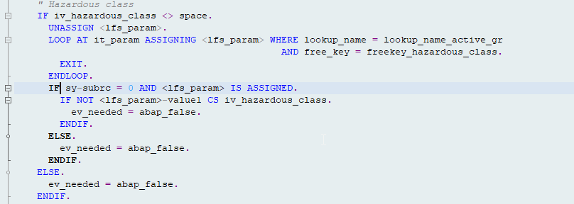

- Class ZCL_MM_COI_UTILITY
Method CHECK_COI_NEEDED_TR –
Seems like wherever you are reading parameter entries you are considering only 1 line. Not considering the possibility of multiple records. This observation is true for checks against PARAM records

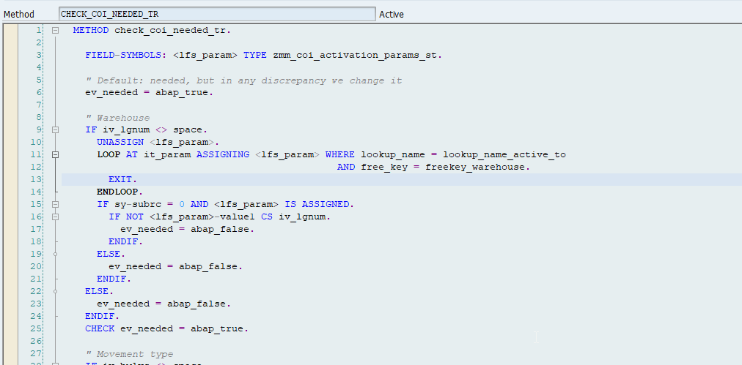

- There is a COI duplicate check in the PROCESS_SCREEN method.
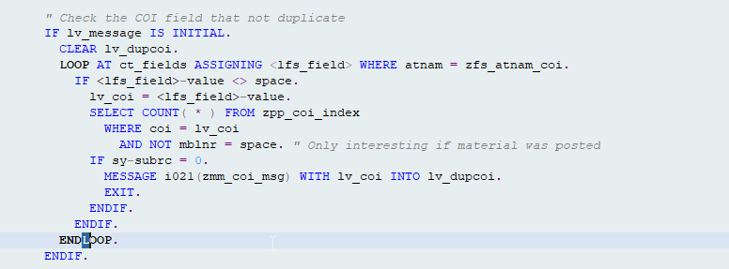

If we do a GR and cancel the GR , does it do a automatic update of the COI table? Are we handling the cancel scenarios?

- Also for the duplicate check should we check the delete indicator.
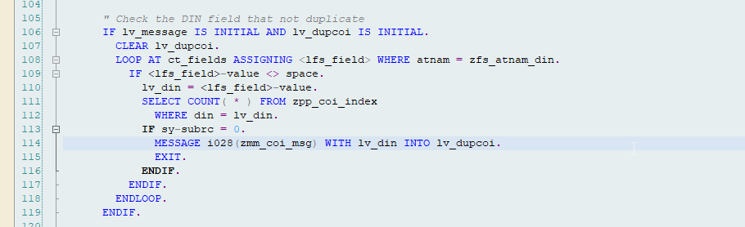

Are deleted records also part of duplicate check?

- Method – CHECK_COI_NEEDED_PO

When we are checking the AUART for PO , it would make sense to check it with plant as a combination . In a hypothetical situation if we are extending a solution to another plant in which this solution needs to be extended to only one of the Proc order types , we will not be able to manage it with current ZVV_PARAM.
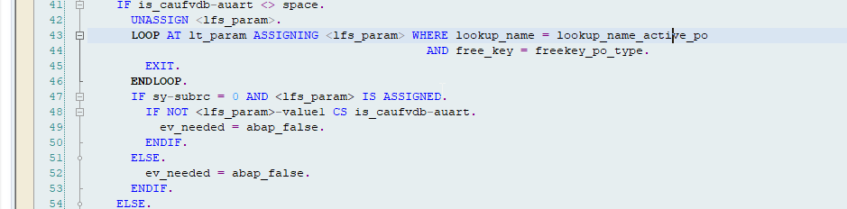

- For a sales order , it is assumed that there will be only 1 COI – Please mention all the working assumptions in DS.
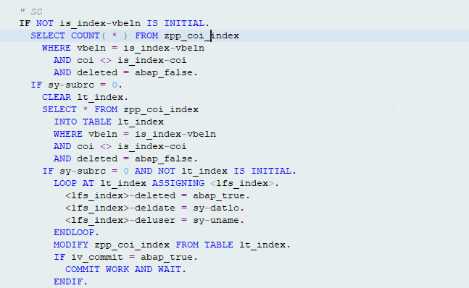

- Please provide a description of the functional requirement in the DS please.
- Process order screen enhancement
ZXCO1O06
Place the modify screen at line 54 within IF – ENDIF.
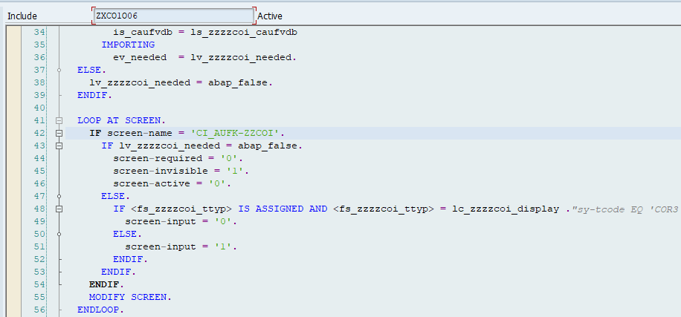

- ZXCO1I05 – Please write more inline comments
- More inline comments please. Please consider this as a generic comment.
Write more inline comments throughout the implementation explaining what is being done there.
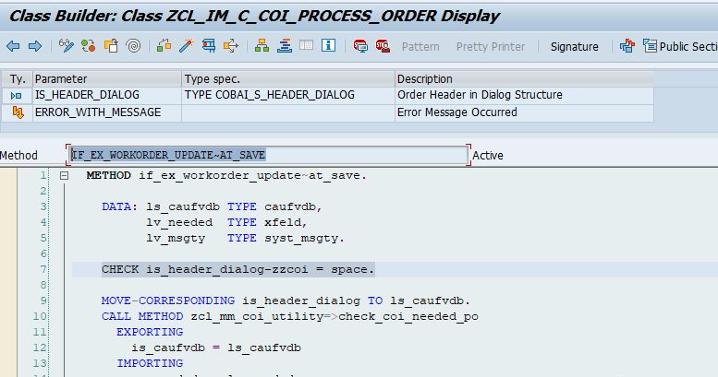

- Need more inline comments please
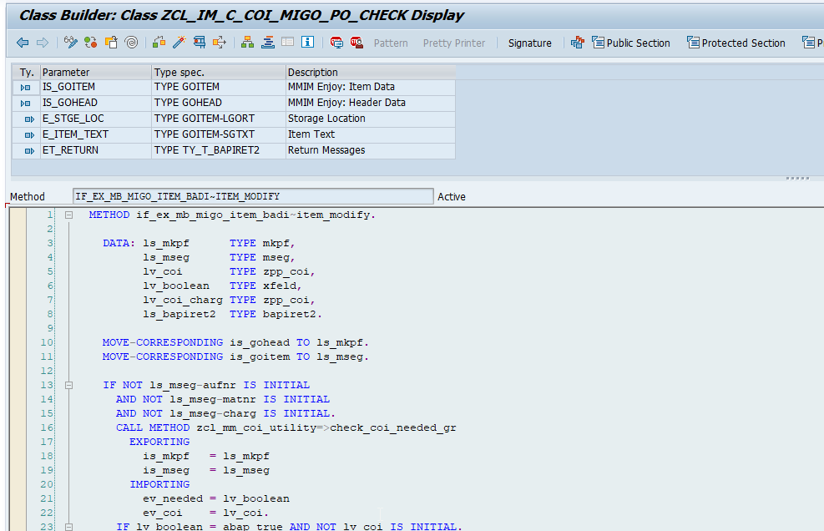

Which process this referring to – Consumption?

- Move the modify screen within IF ENDIF of screen name check
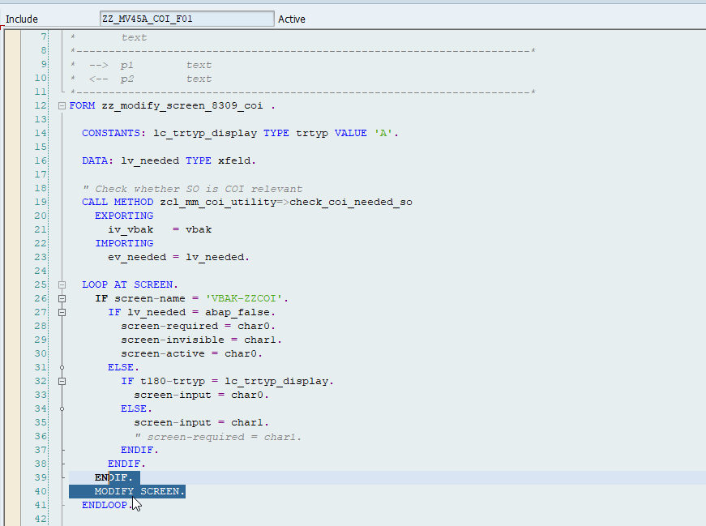

- Not sure if I understand the logic here .
Should gv_zzzzcoi_prev_coi be populated in PBO itself – from VBAK -ZZCOI
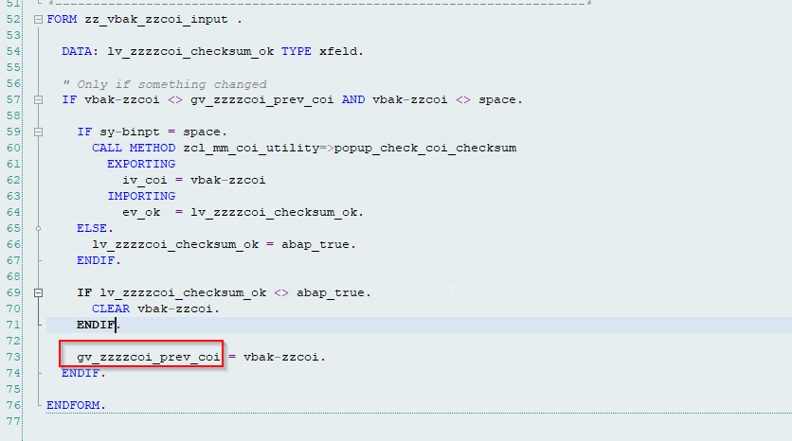

If checksum is not okay – you are clearing the value . Should you also inform why you are clearing it?

- Should all the items of the Sales order should be COI relevant ?
While updating the COI index table for Salesorder , we are not checking if all the items relevant or not.
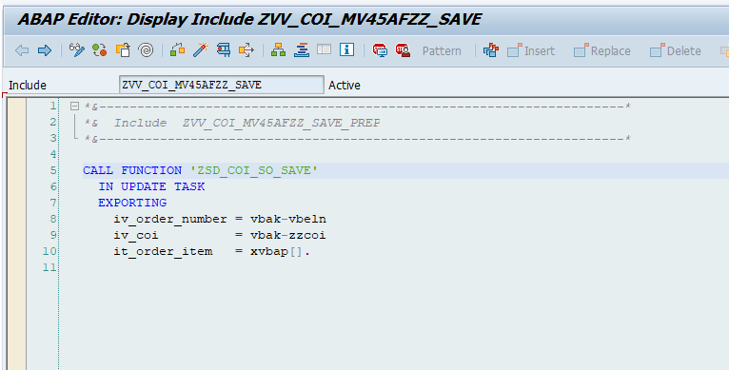

- Is there any validation if a COI number is not entered in the header but a COI relevant batch is used in the salesorder item? Should this scenario not be handled? I guess you are already validating the material .

- For the Report program, ZMR_CHAIN_OF_IDENTITY – SME needs to work with the authorization team to have it assigned to the right roles.
Use a parallel cursor method to go over the loop instead of where condition.
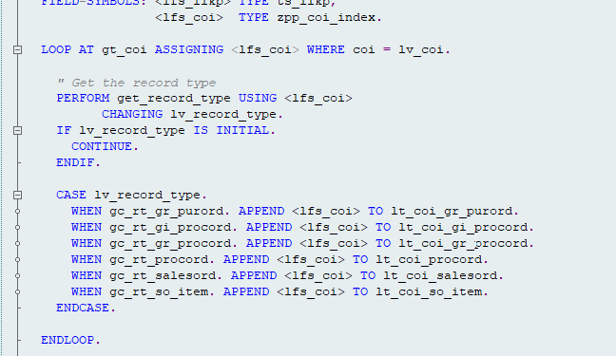

Read Binary search wherever possible please.
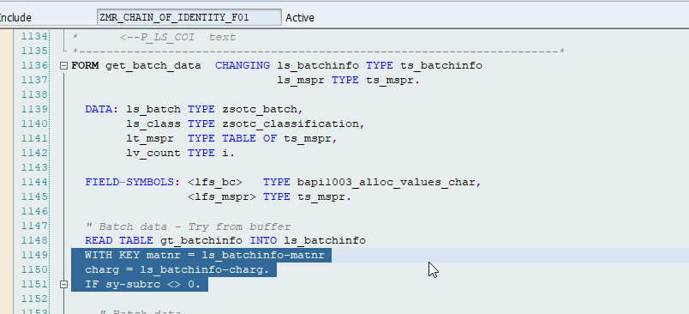

- Seems like you are reading batch characteristics twice.
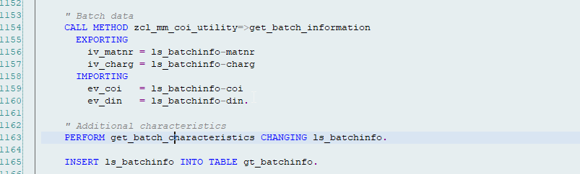

Please access the batch characteristics only once.

- Binary Search Please
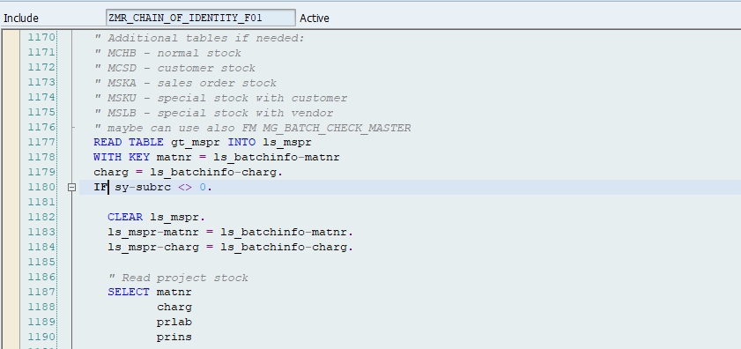

- Can we keep these selections outside the loop and simply do a read inside the loop.
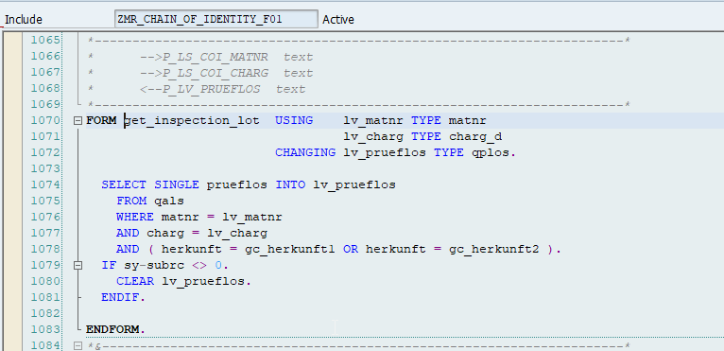

XXXXXXXXXXXXXXXXXXXXXXXXXXXXXXXXXXXXXXXXXXXXXXXXXXXX

- I see that the delivery does not have a separate param check –which is fine in general cases but for any situation you would like to switch off the delivery logic alone – then it is not possible here.
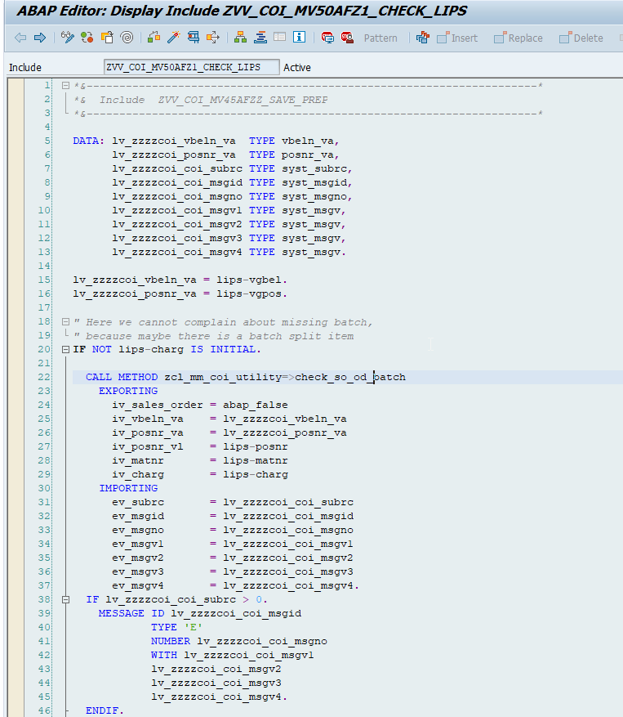

- The below highlighted logic will skip the current line only if it is batch split scenario. What will happen if you are saving the delivery(No batch split) without any batch assigned. The logic will not skip – but continue to next piece of code and it will give an error since the batch is missing . My question is – In COI process , is it not possible to create a delivery without assigning batch to it? Or am I missing something?

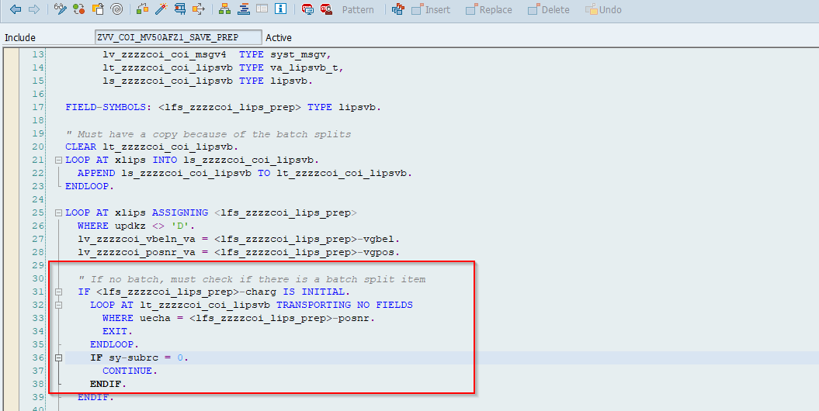

- I also feel that the org checks are happening only after the material and batch check.
I believe it should be the other way . Unnecessarily reading the batch and material characteristics for the organizations where this solution is not implemented creates additional overhead. Can we please have this corrected?
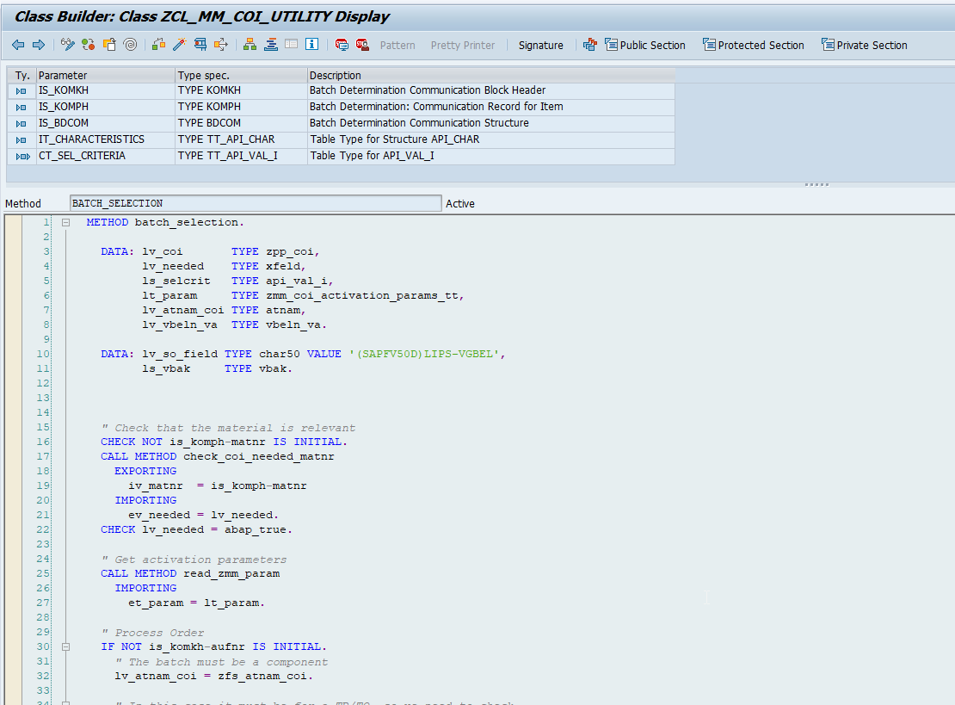

- Why are we specifically checking sy-subrc = 4?
E_subrc eq 0 will not work.? Or e_msgid eq space?
